UNIT 4
VT IN CLOUD COMPUTING

4.1. Introduction to Virtualization Technology:
- Virtualization is a technique of how to separate a service from the underlying physical delivery of that service.
- It is the process of creating a virtual version of something like computer hardware.
- It was initially developed during the mainframe era.
- It involves using specialized software to create a virtual or software-created version of a computing resource rather than the actual version of the same resource.
- With the help of Virtualization, multiple operating systems and applications can run on same machine and its same hardware at the same time, increasing the utilization and flexibility of hardware.
- In other words, one of the main cost effective, hardware reducing, and energy saving techniques used by cloud providers is virtualization.
- Virtualization allows to share a single physical instance of a resource or an application among multiple customers and organizations at one time.
- It does this by assigning a logical name to a physical storage and providing a pointer to that physical resource on demand.
- It is the "creation of a virtual (rather than actual) version of something, such as a server, a desktop, a storage device, an operating system or network resources".
- In other words, Its a technique, which allows to share a single physical instance of a resource or an application among multiple customers and organizations.
- It is also known as changing the mindset from physical to logical.
- Moreover, virtualization technologies provide a virtual environment for not only executing applications but also for storage, memory, and networking.
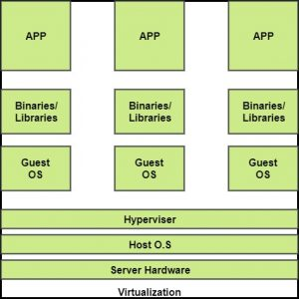

Concept of Virtualization:
- Creation of a virtual machine over existing operating system and hardware is known as Hardware Virtualization.
- A Virtual machine provides an environment that is logically separated from the underlying hardware.
- The machine on which the virtual machine is going to create is known as Host Machine and that virtual machine is referred as a Guest Machine
Benefits of virtualization
1. More flexible and efficient allocation of resources.
2. Enhance development productivity.
3. It lowers the cost of IT infrastructure.
4. Remote access and rapid scalability.
5. High availability and disaster recovery.
6. Pay peruse of the IT infrastructure on demand.
7. Enables running multiple operating systems.
Types of Virtualizations:
1.Application Virtualization.
2.Network Virtualization.
3.Desktop Virtualization.
4.Storage Virtualization.
5.Server Virtualization.
6.Data virtualization.
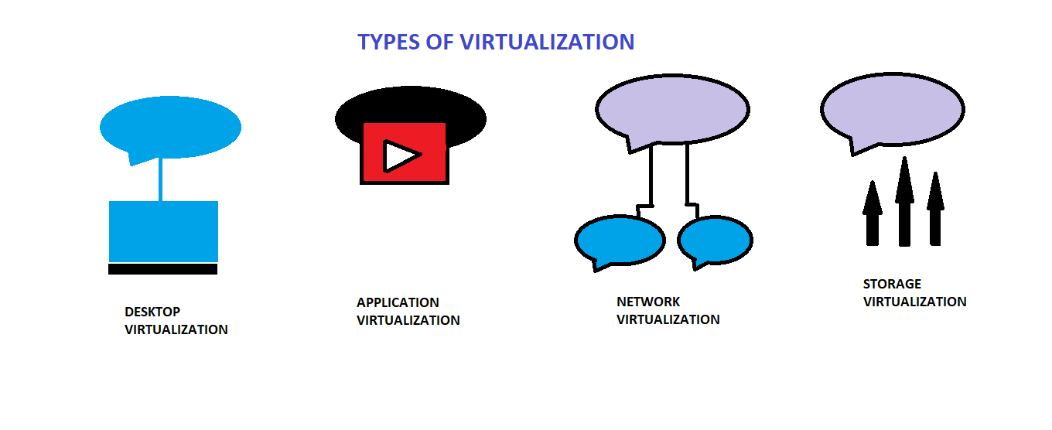
1. Application Virtualization:
- Application virtualization helps a user to have remote access of an application from a server. The server stores all personal information and other characteristics of the application but can still run on a local workstation through the internet. Example of this would be a user who needs to run two different versions of the same software. Technologies that use application virtualization are hosted applications and packaged applications.
2. Network Virtualization:
- The ability to run multiple virtual networks with each has a separate control and data plan. It co-exists together on top of one physical network. It can be managed by individual parties that potentially confidential to each other. Network virtualization provides a facility to create and provision virtual networks—logical switches, routers, firewalls, load balancer, Virtual Private Network (VPN), and workload security within days or even in weeks.
3. Desktop Virtualization:
- Desktop virtualization allows the users’ OS to be remotely stored on a server in the data centre. It allows the user to access their desktop virtually, from any location by a different machine. Users who want specific operating systems other than Windows Server will need to have a virtual desktop. Main benefits of desktop virtualization are user mobility, portability, easy management of software installation, updates, and patches.

4. Storage Virtualization:
- Storage virtualization is an array of servers that are managed by a virtual storage system. The servers aren’t aware of exactly where their data is stored, and instead function more like worker bees in a hive. It makes managing storage from multiple sources to be managed and utilized as a single repository. storage virtualization software maintains smooth operations, consistent performance and a continuous suite of advanced functions despite changes, break down and differences in the underlying equipment.

5. Server Virtualization:
- This is a kind of virtualization in which masking of server resources takes place. Here, the central-server (physical server) is divided into multiple different virtual servers by changing the identity number, processors. So, each system can operate its own operating systems in isolate manner. Where each sub-server knows the identity of the central server. It causes an increase in the performance and reduces the operating cost by the deployment of main server resources into a sub-server resource. It’s beneficial in virtual migration, reduce energy consumption, reduce infrastructural cost, etc.

6. Data virtualization:
- This is the kind of virtualization in which the data is collected from various sources and managed that at a single place without knowing more about the technical information like how data is collected, stored & formatted then arranged that data logically so that its virtual view can be accessed by its interested people and stakeholders, and users through the various cloud services remotely. Many big giant companies are providing their services like Oracle, IBM, At scale, Cdata, etc
Working or virtualization in Cloud Computing
- Virtualization plays a very important role in the cloud computing technology, normally in the cloud computing, users share the data present in the clouds like application etc, but actually with the help of virtualization users shares the infrastructure.
- The main usage of Virtualization Technology is to provide the applications with the standard versions to their cloud users, suppose if the next version of that application is released, then cloud provider has to provide the latest version to their cloud users and practically it is possible because it is more expensive.
- To overcome this problem we use basically virtualization technology, By using virtualization, all severs and the software application which are required by other cloud providers are maintained by the third party people, and the cloud providers has to pay the money on monthly or annual basis.
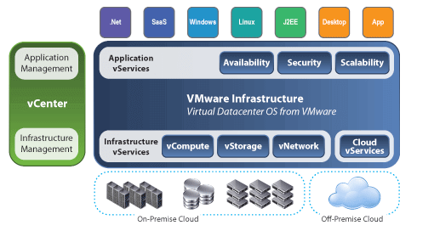
4.2. Hypervisor:
- A hypervisor, also known as a virtual machine monitor or VMM, is software that creates and runs virtual machines (VMs).
- A hypervisor allows one host computer to support multiple guest VMs by virtually sharing its resources, such as memory and processing.
- It’s a software layer that runs between host machine (physical server) and guest machine (virtual machine)
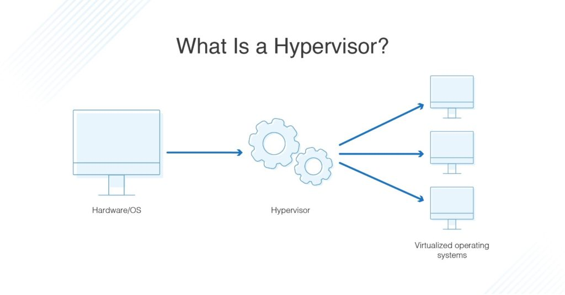
Benefits of hypervisors:
There are several benefits to using a hypervisor that hosts multiple virtual machines:
Speed: Hypervisors allow virtual machines to be created instantly, unlike bare-metal servers. This makes it easier to provision resources as needed for dynamic workloads.
Efficiency: Hypervisors that run several virtual machines on one physical machine’s resources also allow for more efficient utilization of one physical server. It is more cost- and energy-efficient to run several virtual machines on one physical machine than to run multiple underutilized physical machines for the same task.
Flexibility: Bare-metal hypervisors allow operating systems and their associated applications to run on a variety of hardware types because the hypervisor separates the OS from the underlying hardware, so the software no longer relies on specific hardware devices or drivers.
Portability: Hypervisors allow multiple operating systems to reside on the same physical server (host machine). Because the virtual machines that the hypervisor runs are independent from the physical machine, they are portable. IT teams can shift workloads and allocate networking, memory, storage and processing resources across multiple servers as needed, moving from machine to machine or platform to platform. When an application needs more processing power, the virtualization software allows it to seamlessly access additional machines.
Need of hypervisor:
- Hypervisors make it possible to use more of a system’s available resources and provide greater IT mobility since the guest VMs are independent of the host hardware.
- This means they can be easily moved between different servers.
- Because multiple virtual machines can run off of one physical server with a hypervisor, a hypervisor reduces:
- Space
- Energy
- Maintenance requirements
Types of Hypervisors:
Type 1:
- A type 1 hypervisor, also referred to as a native or bare metal hypervisor, runs directly on the host’s hardware to manage guest operating systems.
- It takes the place of a host operating system and VM resources are scheduled directly to the hardware by the hypervisor.
- This type of hypervisor is most common in an enterprise data center or other server-based environments.
- Microsoft Hyper-V, and VMware vSphere are examples of a type 1 hypervisor.
Pros & Cons of Type-2 Hypervisor:
Pros: Such kind of hypervisors are very efficient because they have direct access to the physical hardware resources (like Cpu, Memory, Network, Physical storage). This causes the empowerment the security because there is nothing any kind of the third party resource so that attacker couldn’t compromise with anything.
Cons: One problem with Type-1 hypervisor is that they usually need a dedicated separate machine to perform its operation and to instruct different VMs and control the host hardware resources.

Type 2:
- A type 2 hypervisor is also known as a hosted hypervisor, and is run on a conventional operating system as a software layer or application.
- It works by abstracting guest operating systems from the host operating system. VM resources are scheduled against a host operating system, which is then executed against the hardware.
- A type 2 hypervisor is better for individual users who want to run multiple operating systems on a personal computer.
- VMware Workstation and Oracle VirtualBox are examples of a type 2 hypervisor.
Pros & Cons of Type-2 Hypervisor:
Pros: Such kind of hypervisors allows quick and easy access to a guest Operating System alongside the host machine running. These hypervisors usually come with additional useful features for guest machine. Such tools enhance the coordination between the host machine and guest machine.
Cons: Here there is no direct access to the physical hardware resources so the efficiency of these hypervisors lags in performance as compared to the type-1 hypervisors, and potential security risks are also there an attacker can compromise the security weakness if there is access to the host operating system so he can also access the guest operating system.

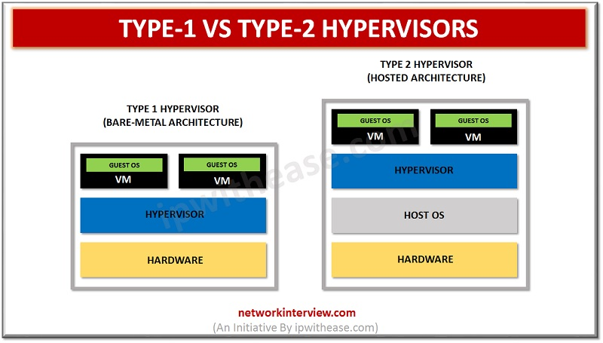
Examples of Hypervisor:
TYPE 1 Examples:
- VMware vSphere with ESX/ESXi:
- VMware is an industry-leading vendor of virtualization technology, and many large data centers run on their products.
- It may not be the most cost-effective solution for smaller IT environments.
- If you do not need all the advanced features VMware vSphere offers, there is a free version of this hypervisor and multiple commercial editions.

- KVM (Kernel-Based Virtual Machine):
- KVM is built into Linux as an added functionality.
- It lets you convert the Linux kernel into a hypervisor.
- It is sometimes confused with a type 2 hypervisor
- It has direct access to hardware along with virtual machines it hosts. KVM is an open-source hypervisor that contains all the features of Linux with the addition of many other functionalities.
- This makes it one of the top choices for enterprise environments.
- Some of the highlights include live migration, scheduling and resource control, alongside higher prioritization.

- Microsoft Hyper-V:
- Despite VMware’s hypervisor being higher on the ladder with its numerous advanced features, Microsoft’s Hyper-V has become a worthy opponent.
- Microsoft also offers a free edition of their hypervisor, but if you want a GUI and additional functionalities, you will have to go for one of the commercial versions.
- Hyper-V may not offer as many features as VMware vSphere package, but you still get live migration, replication of virtual machines, dynamic memory and many other features.

- Oracle VM:
- This hypervisor has open-source Xen at its core and is free.
- Advanced features are only available in paid versions.
- Even though Oracle VM is essentially a stable product, it is not as robust as vSphere, KVM or Hyper-V.

- Citrix Hypervisor (formerly known as Xen Server):
- This Server virtualization platform by Citrix is best suited for enterprise environments.
- It can handle all types of workloads and provides features for the most demanding tasks.
- Citrix is proud of its proprietary features, such as Intel and NVIDIA enhanced virtualized graphics and workload security with Direct Inspect APIs.

TYPE 2 Examples:
- Oracle VM VirtualBox:
- A free but stable product with enough features for personal use and most use cases for smaller businesses.
- VirtualBox is not resource demanding, and it has proven to be a good solution for both desktop and server virtualization. It provides support for guest multiprocessing with up to 32 vCPUs per virtual machine, PXE Network boot, snapshot trees, and much more.
- VMware Workstation Pro/VMware Fusion:
- VMware Workstation Pro is a type 2 hypervisor for Windows OS.
- It is full of advanced features and has seamless integration with vSphere.
- This allows you to move your apps between desktop and cloud environments.
- It does come with a price tag, as there is no free version.
- If you want to take a glimpse into VMware hosted hypervisors free of charge, you can try VMware Workstation Player.
- This is the basic version of the hypervisor suitable for small sandbox environments.
- For MacOS users, VMware has developed Fusion that is similar to their Workstation product.
- It comes with somewhat fewer features, but also carries a smaller price tag.

- MS-Windows Virtual PC:
- It only supports Windows 7 as a host machine and Windows OS on guest machines.
- This includes multiple versions of Windows 7 and Vista, as well as XP SP3. Virtual PC is completely free.

- VMware Server:
- VMware Server is a free, hosted virtualization hypervisor that’s very similar to the VMware Workstation.
- VMware has halted development on Server since 2009

- Red Hat Enterprise Virtualization:
- Red Hat’s Kernel-based Virtual Machine (KVM) has qualities of both a hosted and a bare-metal virtualization hypervisor.
- It can turn the Linux kernel itself into a hypervisor so the VMs have direct access to the physical hardware.

4.3. Virtual machines:
- It is a computer resource that uses software instead of a physical computer to run programs and deploy apps.
- Another word VM is a virtual environment that works like a computer within a computer.
- A virtual machine, commonly shortened to just VM, is no different than any other physical computer like a laptop, smart phone, or server.
- It has a CPU, memory, disks to store your files, and can connect to the internet if needed.
- While the parts that make up your computer (called hardware) are physical and tangible, VMs are often thought of as virtual computers or software-defined computers within physical servers, existing only as code.
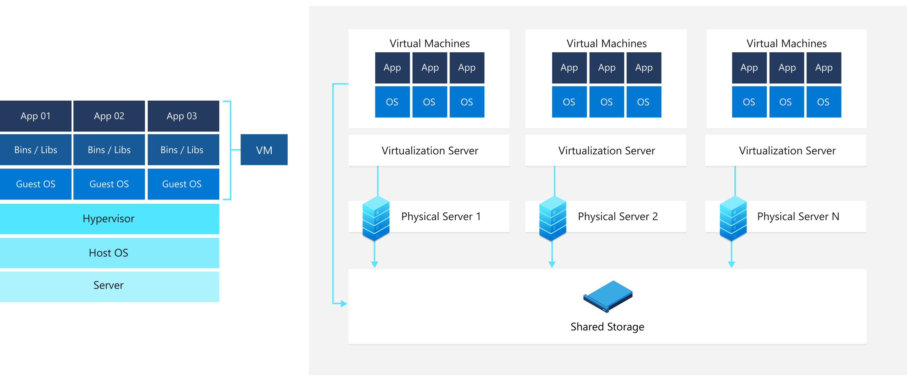

Working of VMs:
- Virtualization is the process of creating a software-based, or "virtual" version of a computer, with dedicated amounts of CPU, memory, and storage that are "borrowed" from a physical host computer—such as your personal computer— and/or a remote server—such as a server in a cloud provider's data center.
- A virtual machine is a computer file, typically called an image, that behaves like an actual computer.
- It can run in a window as a separate computing environment, often to run a different operating system—or even to function as the user's entire computer experience—as is common on many people's work computers.
- The virtual machine is partitioned from the rest of the system, meaning that the software inside a VM can't interfere with the host computer's primary operating system.

Applications of VMs:
- Building and deploying apps to the cloud.
- Trying out a new operating system (OS), including beta releases.
- Spinning up a new environment to make it simpler and quicker for developers to run dev-test scenarios.
- Backing up your existing OS.
- Accessing virus-infected data or running an old application by installing an older OS.
- Running software or apps on operating systems that they weren't originally intended for.

Benefits of VMs:
- Cost savings—running multiple virtual environments from one piece of infrastructure means that you can drastically reduce your physical infrastructure footprint. This boosts your bottom line—decreasing the need to maintain nearly as many servers and saving on maintenance costs and electricity.
- Agility and speed—Spinning up a VM is relatively easy and quick and is much simpler than provisioning an entire new environment for your developers. Virtualization makes the process of running dev-test scenarios a lot quicker.
- Lowered downtime—VMs are so portable and easy to move from one hypervisor to another on a different machine—this means that they are a great solution for backup, in the event the host goes down unexpectedly.
- Scalability—VMs allow you to more easily scale your apps by adding more physical or virtual servers to distribute the workload across multiple VMs. As a result you can increase the availability and performance of your apps.
- Security benefits— Because virtual machines run in multiple operating systems, using a guest operating system on a VM allows you to run apps of questionable security and protects your host operating system. VMs also allow for better security forensics, and are often used to safely study computer viruses, isolating the viruses to avoid risking their host computer.

Disadvantages:
- Running multiple virtual machines on one physical machine can result in unstable performance if infrastructure requirements are not met.
- Virtual machines are less efficient and run slower than a full physical computer. Most enterprises use a combination of physical and virtual infrastructure to balance the corresponding advantages and disadvantages.

Types of virtual machines:
- A process virtual machine allows a single process to run as an application on a host machine, providing a platform-independent programming environment by masking the information of the underlying hardware or operating system. An example of a process VM is the Java Virtual Machine, which enables any operating system to run Java applications as if they were native to that system.

- A system virtual machine is fully virtualized to substitute for a physical machine. A system platform supports the sharing of a host computer’s physical resources between multiple virtual machines, each running its own copy of the operating system. This virtualization process relies on a hypervisor which can run on bare hardware, such as ESXi or on top of an operating system.

4.4 Cloud storage or Cloud Data center:
- It is a cloud computing model that stores data on the Internet through a cloud computing provider who manages and operates data storage as a service.
- It’s delivered on demand with just-in-time capacity and costs, and eliminates buying and managing your own data storage infrastructure.
- This gives you agility, global scale and durability, with “anytime, anywhere” data access.

Working of Cloud storage:
- It is purchased from a third-party cloud vendor who owns and operates data storage capacity and delivers it over the Internet in a pay-as-you-go model.
- These cloud storage vendors manage capacity, security and durability to make data accessible to your applications all around the world.
- Applications access cloud storage through traditional storage protocols or directly via an API. Many vendors offer complementary services designed to help collect, manage, secure and analyze data at massive scale.

Benefits of Cloud Storage
Storing data in the cloud lets IT departments transform three areas:
- Total Cost of Ownership.
- With cloud storage, there is no hardware to purchase, storage to provision, or capital being used for "someday" scenarios.
- You can add or remove capacity on demand, quickly change performance and retention characteristics, and only pay for storage that you actually use.
- Less frequently accessed data can even be automatically moved to lower cost tiers in accordance with auditable rules, driving economies of scale.
- Time to Deployment.
- When development teams are ready to execute, infrastructure should never slow them down.
- Cloud storage allows IT to quickly deliver the exact amount of storage needed, right when it's needed.
- This allows IT to focus on solving complex application problems instead of having to manage storage systems.
- Information Management.
- Centralizing storage in the cloud creates a tremendous leverage point for new use cases.
- By using cloud storage lifecycle management policies, you can perform powerful information management tasks including automated tiering or locking down data in support of compliance requirements.

Cloud Storage Requirements:
There are several fundamental requirements when considering storing data in the cloud.

- Durability. Data should be redundantly stored, ideally across multiple facilities and multiple devices in each facility. Natural disasters, human error, or mechanical faults should not result in data loss.

- Availability. All data should be available when needed, but there is a difference between production data and archives. The ideal cloud storage will deliver the right balance of retrieval times and cost.

- Security. All data is ideally encrypted, both at rest and in transit. Permissions and access controls should work just as well in the cloud as they do for on premises storage.

Types of Cloud Storage:
There are three types of cloud data storage: object storage, file storage, and block storage.

- Object Storage - Applications developed in the cloud often take advantage of object storage's vast scalability and metadata characteristics. Object storage solutions like Amazon Simple Storage Service (S3) are ideal for building modern applications from scratch that require scale and flexibility, and can also be used to import existing data stores for analytics, backup, or archive.
- File Storage - Some applications need to access shared files and require a file system. This type of storage is often supported with a Network Attached Storage (NAS) server. File storage solutions like Amazon Elastic File System (EFS) are ideal for use cases like large content repositories, development environments, media stores, or user home directories.
- Block Storage - Other enterprise applications like databases or ERP systems often require dedicated, low latency storage for each host. This is analogous to direct-attached storage (DAS) or a Storage Area Network (SAN). Block-based cloud storage solutions like Amazon Elastic Block Store (EBS) are provisioned with each virtual server and offer the ultra-low latency required for high performance workloads.

4.5. Virtualization in Cloud Computing:

- In the context of cloud computing, virtualization is a technique that makes a virtual ecosystem of storage devices and the server OS.
- In that case, virtualization enables users to use various machines that share one particular physical instance of any resource.
- Cloud virtualization transforms the traditional computing methods such that the workload management is more efficient, economic and scalable.
- Virtualization concerning Cloud Computing is being unified swiftly, and advancing the conventional course of computing such as virtualization is helping in the sharing of applications across a network thread of several enterprises and active users.
- Since cloud computing is being considered as a service or an application, assisting a virtualized ecosystem that could either be private or public, so with virtualization, resources could be escalated, reducing the necessity for a physical system.

